

The Boeing 737-Max 8 Incident and the Future of Autonomous Aviation

By

Miguel Ibrahim

ID: 202005354

CSC480: Social and Professional Issues in Computer Science

Dr. Ramzi Haraty

**Contents**

**I.** **INTRODUCTION:** 3

**II.** **AUTONOMY:** 4

**III.** **Certifying a plane:** 5

**IV.** **History of the Boeing 737** 7

**V.** **Making a plane efficient** 8

**VI.** **The 737 Max-8 incident** 9

**VII.** **Opinion** 11

**VIII.** **The Future of Aviation** 15

**IX.** **Conclusion** 16

**X.** **References** 17

# **INTRODUCTION:**

Everything begins with a dream or an accident. The first pane wasn't an ingenious idea created by giant cooperation. It was two brothers, the Wright brothers, who accidentally made their bicycle lift off the ground by providing the necessary lift it needed (Stimson, 2022). This then gave them the idea of inventing the airplane. However, these brothers weren't the first to invent flying, in the baroque period, Leonardo Davinci sketched a wingsuit that created headlines nowadays, unfortunately, the idea of a patent didn’t exist in Davinci’s time (1452-1519).

What’s a patent? According to WIPO- World Intellectual Property Organization, “a patent is an exclusive right granted for an invention, which is a product or a process that provides, in general, a new way of doing something, or offers a new technical solution to a problem.” A patent allows its owner to stop others from copying their patented invention, a good example of a patent is the light bulb, the computer, the telephone, and other major things we use today.

After all these patents and inventions, William E. Boeing, a wealthy entrepreneur from the University of Yale, was so fascinated with airplanes that he bought a wooden boat manufacturing plant to be his hub for manufacturing airplanes (Schefke, 2018). In June 1916, the first Boeing plane B & W was manufactured. Of course, being a manufacturing plant in both WW1 and WW2, the Boeing company became very lucrative and a reputable brand in the airline industry. They then started to develop the Boeing 707 plane for the commercial market as the reliable brand Americans and Europeans knew of at that time (Bauer, 2018).

The main competitor to Boeing is Airbus- a company that had been producing planes since 28 October 1969*,* the first plane to be built is the A300 to replace the three-engine competitors such as the MD-11 (MacDonnell Douglas). McDonnell Douglas was a major aerospace company that merged with Boeing in 1997, they used to create very questionable and controversial planes in the past, which later trickled down to Boeing. On the other hand, Airbus is a large company that gathers expertise in airplane part building across the European Union to build planes together in its many hubs located from Toulouse to Tianjin (Airbus, 2021).

# **AUTONOMY:**

Autonomic control started when the great depression ended (Groover, 2020). With the surge in population and demand after a decade of depression, companies need to find a way to produce more food at fewer overall cost. The first autonomous object in the world was at the 1939 World's Fair the first-ever autonomous object was an electric car that was created by General Motors and turned into a reality in 1958 (Computer History Museum, 2020). Humans always strived towards autonomy, creating things manually diverted their attention from what was deemed valuable to them. These days people are moving towards a workaholic habit of putting their work before their family and becoming furious when things at home are prepared when they arrive (Clockify, 2017). Before countries strive towards a more modernized household, they need to provide the necessary functionalities and basic recourses such as electricity, water, garbage disposal, and sewage systems. When these primary needs are set, people (with enough amount of money) can move towards modernizing their household by providing fast and reliable internet, up-to-date appliances, or smart homes if deemed necessary.

The term Autonomy was coined by Immanuel Kant and John Stuart. For Kant, if a person's choices and actions are not influenced by external factors such as peer pressure and desires, then they are autonomous (Britannica, 2017).

There are six different kinds of autonomy in the car industry: The first kind of autonomy is none, and the second type is monitoring speed (cruise control). The third is partial automation performing steering and acceleration. The vehicle can perform most driving tasks for type 3 and 4 autonomy but still needs an optional human override to make sure that they are still awake. For the last type, the vehicle can perform all driving tasks with no human intervention (Choksey & Wardlaw, 2021).

For the airline industry, however, the real challenge is the increase in probabilistic failures when it comes to flying very high above the ground. It is widely known that the further up someone goes the more they are subjected to solar radiation (EPA, 2022), for airplanes, the radiation from the sun must not affect the normal and automatic functions of the plane. To solve this issue, airplanes keep their systems redundant in case bit flips occur, or a general system failure. Bit flips caused by solar radiation are one of the main factors of crashes in the airline industry and are known as the most important factor for causing premature hardware failures in devices and is often debated on how to solve this issue. One example is from The Register where they mentioned that the possibility of a bit happening “increases with altitude” (2019), Bit flips are the instantaneous change in the bit characteristic within milliseconds- 00001 to 00000 for example can cause major problems, especially on systems that have up to a maximum certified 853 passengers according to Airbus (2021).

Autonomy in airplanes has improved since the 20th century, planes can do automatic “cruise control”, “altitude control”, and “direction control”; however, these functions need to be done by hand and inputted into the machine so it can execute them. The most recent invention is automatic landing features being implemented in airports (O’Callaghan, 2019), this feature communicates with planes via a private wavelength to see how far, fast, and high up a plane is to assist it to land smoothly. Airbus has implemented this feature in its recent planes, and it is being adopted by all planes nowadays, it can also be noted that 90% of the flying process is done automatically nowadays by inputting the waypoints into the system so that planes can follow it as it exactly specifies (Cheung, 2021).

# **Certifying a plane:**

Certification is an important process that guarantees whether an item is deemed worthy enough to enter the market. There exist multiple characteristics and bullet points to tick off when certifying an item: Energy Efficiency, Noise Emissions, CO2 & NO2 Emissions, Fuel Efficiency, Safety Rating, and Shelf Life are one of the main characteristics to check when certifying an item to release into the market (NSF, 2022). Most of these certification processes are done towards a more sustainable future and most of them are coined by the EU.

On the other hand, certifying a plane is a much more painful process than a home appliance, one of the main plane certifiers- The Federal Aviation Administration (FAA)- takes extreme caution when certifying a plane, testing all its functionalities to full stress to make sure the passenger is safe. Some of these tests can be done in-house, Boeing, Rolls Royce, and other airplane engine manufacturers, for example, have been doing bird strike tests in their hubs for as long as they can remember (Rolls Royce, 2021). Similarly, there exist multiple different aircraft certifications worldwide, in Europe, the European Union Aviation Safety Agency (EASA), The Civil Aviation Administration of China (CAAC), and others. Normally these airplane certification authorities exist in countries that make planes like China, Brazil, the United States of America, Europe, and Canada.

“The Federal Aviation Administration includes more than 1,300 engineers, scientists, inspectors, test pilots, and other experts that are responsible for oversight of design, production, airworthiness certification, and continued airworthiness programs for all U.S. civil aviation products and import products.” (Federal Aviation Administration, 2022) More information is available on the FAA's certification page mentioned in the references.

For a plane to be certified it needs to comply with the authoritative rules of aviation. The rules mainly suggest that the airplane shall not be targeted towards the death of people, to develop a plane is to think of the passenger's safety and not the revenue of a set product, a manufacturer must inform the pilots, airlines, and certification authorities of any system and integrity modifications that may or may not harm the integrity of the airlines business and the safety of its passengers (International Civil Aviation Organization, n.d).

Additional things that an airplane manufacturer must keep in mind are the certification bullet points mentioned above. With the increase in temperature around the globe, countries and governmental personnel are receiving massive amounts of pressure from their citizens to do something about climate change, for this to happen, airplane manufacturers must keep on spending their money on research and development to make sure that what they produce is much more efficient than what was before (Hamilton,2022). Efficiency on airplanes is usually measured using the amount of fuel it consumes per passenger, and its environmental impact. The upcoming most efficient aircraft is the Boeing 777X which will be released in 2025. The current most efficient aircraft is between the Boeing 787 and the Airbus A350XWB, which both proved successful in the market with no accidents yet (Thomas, 2022).

Unfortunately, not everything is perfect, the 787 and the A350 both use a composite material called carbon fiber and resin; however, Qatar airways seems to have an issue with the A350, particularly with the early degradation of its paint. This issue is mainly due to the contact between the paint and the lightning conductor that is fitted onto the plane since carbon fiber is not conductive enough. Which lead Qatar to sue Airbus for a sum of USD 220 million (Reuters, 2022).

# **History of the Boeing 737**

The Boeing 737 was first introduced in April 1967 and entered service in 1968. The first Boeing 737 was the 737-100. The naming scheme of the Boeing family is simple, the model numbers are usually characterized by the number in the middle between the sevens such as the 777, or 737, this in turn defines the model of the airplane and its specifications. The number after the dash signifies the capacity a plane can hold, how far it can fly, and its efficiency. The 737-100's goal is to create a low-to-the-ground airplane to make baggage handling easier, this was implemented before technology in baggage handling was improved. The Boeing 737 was also invented for carrying a reasonable number of passengers on medium-haul flights, a medium-haul flight is characterized by a flight that lasts between 3 to 6 hours making Boeing's 737 the best seller around the world, second to Cessna 172 (CNN, 2022)

This airplane proved to be the best-selling plane in the world selling around 11,117 planes as of August 2022 according to Boeing and simple flying, the reason behind this is the average cost of $106 Million. This plane proved to be so popular that many airline companies wanted a more efficient Boeing 737, thus the Boeing 737 Max family came into existence. In fact, according to the New York Times headline: "Boeing Was 'Go, Go, Go' to Beat Airbus With the 737 Max", more recent claims depict that the reason why Boeing created this plane in the first place is due to competition (2019), Jon Hemmerdinger from flight global strongly suggest that the Airbus’ first move to launch its new A320 neo forced the production and the launch of the 737 MAX (2021). The A320 neo’s "neo" stood for new engine option according to Airbus, the new engine option is the same old A320 design and frame, but now with a new, much improved, and efficient engine. The A320 neo comes with two choices of an engine that is geared instead of not being geared, a geared engine in an airplane is similar to a geared transmission in a car, allowing the fan blades to spin faster than the interior blades and vice versa. This allowed Airbus to reduce a total of 4% fuel burn over longer sectors “**corresponding to an annual reduction in CO2 emissions of around 900 tonnes per aircraft.” (Airbus, n.d.) This then forced Boeing to release a similar plane but in the shape of a 737 later called the 737 MAX variant, which is one of the reasons behind its crash.**

# **Making a plane efficient**

There exist many ways to make a plane work more efficiently: improving the engine efficiency, using more lightweight material, and changing the hydraulic systems to electronic such as the fly by wire.

Currently, the most efficient plane- the Airbus A350 uses a combination of all the above-mentioned ways to improve efficiency (One Monroe Aerospace, 2019). Changing the haul to a more composite carbon fiber resin allowed the airplane to experience more stress- this stress can be from many factors: cabin air pressure versus outside pressure, airplane inclination, speed, and total airplane weight. The Airbus XWB variant which stands for Extra Wide Body also experienced a change in its engine to a more efficient Rolls Royce XWB. According to Rolls Royce, the engine experiences a 15% Fuel Consumption advantage over the original Trent engine which also saved $2.6M on fuel alone (Rolls Royce, 2022).

Boeing sought to improve its 737-800/737NG variant through its successful dominance in the market; however, the main problem with the 737 is mentioned above. To improve a plane's efficiency is to improve the above-mentioned aspects; however, carbon fiber is an expensive option that would quadruple the price of a standard 737, to solve this problem at the least cost possible, they would use a 737-800 body, but with a bigger engine. However, they scrapped that idea and decided to build a haul that resembles the 737 with more efficient engines produced by CFM- a 50/50 joint company with General Electric and Safran Group called the Leap 1B.

Later comparing the different engines between the A320 neo and the 737 Max 8, one may notice the similarities in their naming scheme except for the B and A; however, CFM shows that the LEAP-1A produces: “24,500 – 33,000 pounds thrust (35 000 at altitude)” vs the leap-1B with “23,000 – 28,000 pounds thrust” (n.d.).

A question that may be asked is how a bigger one equates to better efficiency. According to NASA, shrinking the core of an engine vs the entire size of the engine increases the bypass ratio "meaning the fuel burn rate is only slightly changed by the addition of the larger inlet fan. Therefore, the engine generates more thrust for roughly the same fuel burn, making it more efficient (2021).”

# **The 737 Max-8 incident**

The problem with placing a bigger engine of the same frame as the 737-800 is that the engine on that model is already squashed from the bottom, and cannot accommodate a bigger engine, to solve this, Boeing pushed the engine upwards to allow enough room for clearance between the engine and the ground. However, this made the center of gravity fall backward from the center, making the plane tilt backward now and then.

Below is a picture I took of the 737-800 from an aircraft Pegasus owns:

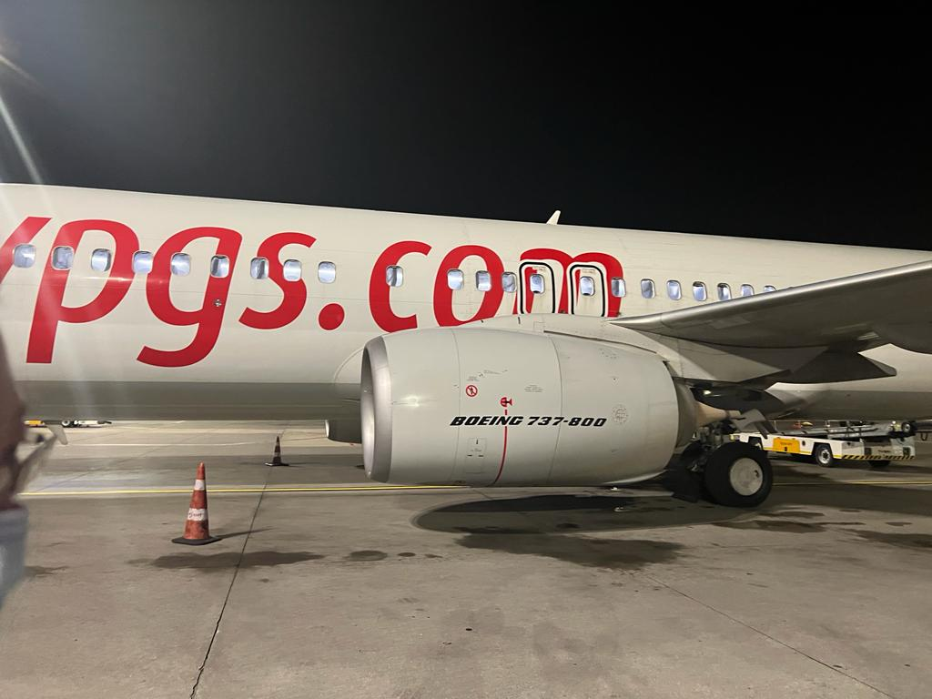

With much respect to: <https://www.flypgs.com/>

Although it might seem that the engine is looking fine and not squashed from the bottom is exactly the issue because it is not the engine that is squished, but the encasing. Using another picture taken from aircraftnerd.com, it can be noted that the encasing is truly flat: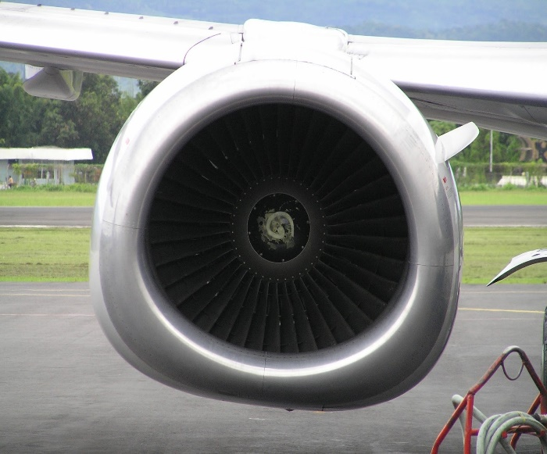

Taken from: <https://www.aircraftnerds.com/2017/04/why-do-boeing-737-engines-have-flat-bottom.html>

In comparison, the 737-Max engines look like so:

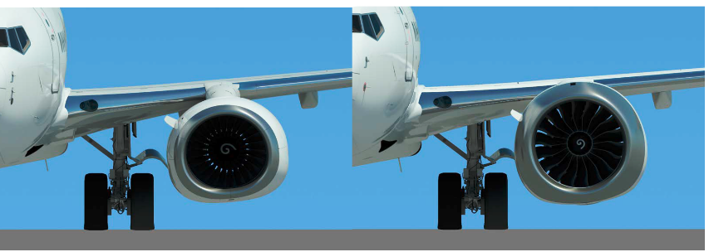

From: https://leehamnews.com/2018/11/14/boeings-automatic-trim-for-the-737-max-was-not-disclosed-to-the-pilots/

On the left: Boeing 737-800, and on the right: 738-Max 8. It can be noted that the placement of the Max engines is higher than the dash 800 engines due to the clearance issues to the ground.

To solve the change in center of gravity due to the higher position of the engine, Boeing fitted a software-controlled system called the MCAS which stands for Maneuvering Characteristics Augmented System. Therefore, allowed the software to push down the nose when the automated system says that the nose is pointing upwards when not needed to, this is used to counteract stalling created by the excessive turbulence created by turbulent flow above the elevator. The previous was used to control the lateral movements of an aircraft most notably referred to as "pitch". On October 29, 2018, Lion Air Flight 610 departed from Soekarno–Hatta International Airport (Jakarta) to Indonesia had an uneventful take-off, this was all about to change when the crew was cruising. While the cabin-crew were cruising, the airplane suddenly started to pitch downwards out of nowhere, this was fixed via manual input to pitch it upwards. After some time, the system saw that the nose was pitched upwards and pushed the nose downwards to fight it; however, manual input couldn’t fix this issue, after a moment the plane disappeared off the grid to be found by the Indonesian government in the Java Sea. 5 months later, Ethiopian Airlines experienced the same problem and crashed in Ethiopia less than 5 minutes after take-off.

# **Opinion**

After all that is discussed above it is about time to discuss that event, after all, that everybody has been through, it is important to keep in mind that there are lives lost after that incident and a large sum of money lost as well, so they must be respected and remembered while writing, and reading this report. Before beginning with the mistake Boeing made, it is important to mention the fact and existence of competition in the aviation market. Before the Max 8 was sought out to the market, a dominant airline manufacturer Airbus created a plane called the A320-neo, the neo stood for new engine option, this means that the same famous A320 will be getting a much better engine for its already existing a320. With that Airbus could produce an airplane that has similar characteristics to its old A320 but now with a much improved and efficient engine, which caught the market by surprise and sold 3,257 airplanes by the 4rth quarter of 2015 according to Reuters. However, this did not sit well with Boeing, they wanted to tap into the market that Airbus had, and airline companies wanted Boeing to join as well for its well-received reputation. However, the main issue with the Boeing 737 is its low-to-the-ground characteristics that were made for easier baggage handling, Airbus did not have that issue however, they were capable of installing a bigger more efficient Pratt & Whitney's PurePower PW1100G-JM geared turbofan, or CFM International's LEAP-1A (Airbus, 2022) according to the airline company’s preference, while the Boeing 737 Max 8 uses CFM International LEAP-1B engines (General Electric, 2016). Beginning with the mistake Boeing made, Boeing created a plane that seemed to not be defective, it proved that it could go long distances with a capability of a single Economy Class cabin accommodating 197 Zodiac Z110 slimline seats (Ryanair, 2018) on the 737 Max-8-200 which is a variant of the Max 8 whilst being efficient with a consumption of 2.28 L/100 km fuel per seat (Boeing, 2017). Note that the previous data can change drastically from the length of the flight to the take-off and landing conditions. Later, more issues will surface, and they will be discussed below, it is important to note that the A320 neo never had any fatal issues. Fortunately, there is no need to worry about these issues, for flying is one of the safest ways to travel, with the availability of Air Traffic Control, great emergency services, and up-to-date pilot training with simulators, flying has become very safe and reliable. It can also be noted that with the increase in certification testing and hard training and courses the number is 0.04 deaths per 100 million miles traveled (Aviation and plane crash statistics, 2022). Referring to an airline close to home, Middle East Airlines (MEA) has a Pilots and Cadets Training division on a 3000 sqm accommodating four simulators’ bays and includes: Airbus A320 Full Flight Simulator, One A320 and one A330 Flight Training Devices (n.d.).

Why it’s Boeing’s fault? It’s Boeing’s fault because it misled investors into this segment of this market, by attracting them through the idea that it is the same 737 but with better efficiency, longer range, and more seats (Guardian News and Media, 2021). This marketing strategy allowed Boeing to display their new aircraft as a variant of an old aircraft, which allowed them to undergo fewer certification processes than if they were to release a brand-new aircraft. With a decrease in fuel consumption and an increase in both range and capacity, the airline industry rushed towards getting this brand-new aircraft which costs around 121.6 million dollars compared to the popular 737-800's 106.1-million-dollar tag (Salas, 2022). However, this cost both lion air and Ethiopian airlines large sums of money which added up to $ 200Million on Boeing itself (National Briefs) and may increase with individual lawsuits since most people trusted Boeing being the company that has been alive since July 15, 1916, according to the company itself. In fact, according to the Seattle Times, Boeing wanted the FAA to certify the 737-Max 8 as another version of the 737 (Gates et al., 2019); this would limit the need for additional training of pilots, a major cost saving for airline customers. However, with the previously mentioned issue for 737’s center of gravity issues, Boeing convinced the FAA that MCAS could not, which in turn saved Boeing billions of dollars on certification and training pilots, which is not the case because it cost Boeing more than $20 Billion which is much more than what it would’ve cost to certify the plane.

Why it’s not Boeing’s fault? Boeing is not at fault for creating and launching a product like the Max 8. According to one of Mentour Pilot’s videos: “Boeing 737 Stall Escape maneuver, why MAX needs MCAS!!”, the reason why MCAS was implemented is due to the angle of attack the 737 has, the 737 could generate enough lift, so much that it could cause a stall of itself. To explain the angle of attack better, I will be attaching an image:

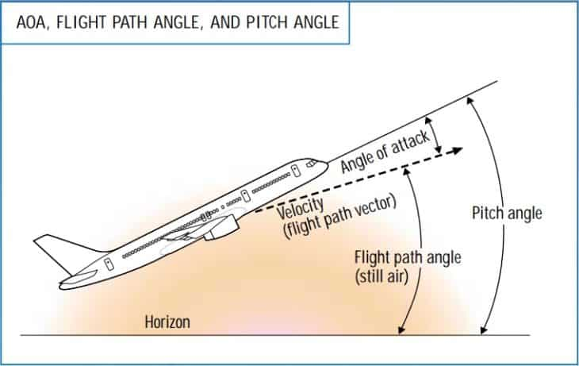 from: https://aerocorner.com/blog/aoa-in-aviation/

A stall is the “breakdown of the smooth airflow over the wing into a turbulent one, resulting in a decrease in lift” (Civil Aviation Authority of New Zealand, 2022). The MCAS allowed the Max aircraft to automatically pitch down before stalling, this is done using many techniques discussed above. The other reason why it’s not Boeing's fault is the increase of demand and pressure from companies that needed an efficient new aircraft, this aircraft proved helpful during the Covid pandemic for transporting low to medium amounts of people for long distances.

It’s the company’s fault mentality: It is scary to see that a plane can plunge quickly out of the sky for a mistake such as not informing the FAA and the airliners of the MCAS software that is implemented in these systems. Boeing has lost a lot of trusts that it has gained from its years of experience creating airplanes; however, it is not surprising to see that 4 rows out of 6 from Clifford Law Offices show that Boeing had the title of “Aircraft that Killed the Most People.” Of these 2/4 are of 737 made with the worst aviation disaster being the "Tenerife Airport Disaster" involving two Boeing 747s exclusive flyers rank the 737 as "the most dangerous plane with 149 accidents and 4,360 fatalities."

Humans are the main cause of error mentality: It’s also not surprising to see that most of the security issues are because of human error, the reason why computer viruses spread is due to humans, and most of the known errors are usually due to negligence and legacy programming that may or may not cost lives and a lot of money. The “Tenerife Airport Disaster” was due to pilot error (Ranter, 1977) a lot of airline incidents are due to human error either due to improper maintenance, design flaw, or pilot error. However, we can never blame other people for things they may not control, problems may occur, and it will always be this way until everything is perfectly automated, which will most likely never be the case.

In my opinion, however, Boeing is at fault when it came to not telling pilots and airline companies that the new 737 had a system that may or may not have cost lives, they are also at fault for cost savings done by Boeing knowing that its value is at 160.01 USD per share according to google finance as per November 6, 2022, with a net worth of *$*87.53B as of November 4 or 95.36B as per the market cap presented by Google. Boeing has the money to spend on making their product secure to the last bolt they install on the airplane, if Airbus could do it, they can also do what stops them. Patents, copyrights, and ethical issues stopped Boeing from copying the A320 NEO, also Boeing was occupied with releasing its 787 variants and its problems as well. I can never blame Boeing for anything however, they create one of the most comfortable airplanes out there I've recently been on their 737-800 and I can't but say how amazing it is to see such a heavy object taking flight in the most beautiful design and sharp aggressive nose. I've noted that their engine is indeed very close to the ground with a flat bottom which surprised me at first and understood why the 737 MAX's engine needed to be higher off the ground, I can certainly say that Boeing's design, comfort, and reliability is much superior to Airbus. On the trips I have been on the A321 and A320 NEOs which are very fast; however, with every turbulent movement it does, it is hard to ignore the constant plastic squeaking it does and the thinness of the aluminum that separates the passenger from the elements outside. Boeing was right about one thing however, by marketing the plane as the same as the old 737, many companies did not need to buy the latest 737 MAX simulator if it was the same as the old plane, this later allowed pilots from the 737-800 to move directly to the 737 Max with little to no training. However, I digress, it is not fair to blame one person for everything, Boeing sought out airline companies to implement an optional feature that added another radar to the system in case the left one is malfunctioning, this will display RDR_DISAG which means the radars are disagreeing (CNN, 2019), the only companies that did not implement this are the low-budget airlines such as the low budget variant of lion air and Ethiopian airlines, who are both involved in the previously mentioned crashes.

# **The Future of Aviation**

Looking forward, the future of aviation is going to be fully autonomous flying, this means that the system will solely rely on the sensors and programming to guide the airplane from one place to another without any human intervention whatsoever. It is also possible to see the cockpit disappearing and being replaced with more seats that might be called "premium seats" or "cockpit seats", all the calculations would be done below the cockpit instead of happening inside the cockpit. Currently, it is easy to see applications such as Flghtradar24 that are capable of tracking planes flying everywhere except private planes, and military planes that are meant to hide. With that, it will be easy to guide a plane through an interconnected network of flight paths and IoT (which may be vulnerable to virus attacks) to guide a plane to a smooth landing, the plane would be capable of contacting weather services to reroute in case of storms, and it can contact military in case of an event. Therefore, there are multiple ways to introduce autonomous flying; however, to implement it one must follow strict guidelines and be very meticulous when designing a plane that carries hundreds of people on board for people’s lives are not games meant to be played with and must be put as a priority before everything else.

How will that impact people? In this course, it is important to discuss the two-edged sword of everything, in this case, this will be great for making flying easy, safe, and efficient; however, it will cause many pilots to lose their jobs, as well as many air-traffic-control and ground services as well. It is important that when one part of a system is autonomous, everything else needs to be that way as well, that includes ATC, ground crew such as baggage handling, and security. One thing that might not change is cabin crew, and maintenance crews, cabin crew will remain important in the airline industry for they are one of the main sources of comfort and safety, seeing cabin crew walking around while the airplane is being turbulent in midair is a relief since most passengers are afraid of heights and turbulence. In addition to the flight crew, the airline industry will seek professionals at designing software to integrate into planes as well as hiring professionals who know how to maintain these various functions. This would most Definity impact the pilots for they have no use anymore in the cockpit for they are being replaced by computers but for now, the pilots will help the AI developer create this system, with help from major automated companies. The role of the maintenance crew will remain vital for they will help in diagnosing the system and replacing the old parts with new ones; however, recent trends might suggest that the aircraft itself can display the problems on board and allocate a robot to fix it using a detailed layout of the structure of the airplane.

# **Conclusion**

In conclusion, competition is what drives companies forward to making their products efficiently, and better than other products so they can seize the market, especially while the demand for set product increases; however, sometimes manufacturers overlook some concerns as "never going to happen" and release the product guaranteeing for it not being a problem in the future, which will most definitely be going to be a problem in the future. In this case, a computer error that cost 346 deaths could be prevented by installing one more angle of attack sensor as well as making their data redundant to the three systems on board, there is no reason for Boeing to rush their product, the market will always be ready to wait for a reputable manufacturer such as Boeing to produce a good aircraft, especially USA based airlines, and some other airlines such as Ryanair, Air China, Korean Air, LOT Polish Airlines, and other airlines who have been buying Boeing aircraft and who operate Boeing only aircraft for generations.

Thank you for reading.

# **References**

1. A, A. (2021, June 15). *Airbus in France*. Airbus. Retrieved November 14, 2022, from https://www.airbus.com/en/our-worldwide-presence/airbus-in-france
2. *A320neo*. Aircraft. (2021, October 7). Retrieved November 18, 2022, from https://aircraft.airbus.com/en/aircraft/a320-the-most-successful-aircraft-family-ever/a320neo
3. *About*. CFM International. (2022, October 13). Retrieved November 19, 2022, from https://www.cfmaeroengines.com/about/
4. Airbus, A. (2021). *En-airbus-A380-facts-and-figures-dec-2021*. Facts and Figures. Retrieved November 15, 2022, from https://www.airbus.com/sites/g/files/jlcbta136/files/2021-12/EN-Airbus-A380-Facts-and-Figures-December-2021_0.pdf
5. Aircraft Nerds. (n.d.). *Why do Boeing 737 engines have flat bottom?* Aircraft Nerds. Retrieved November 19, 2022, from https://www.aircraftnerds.com/2017/04/why-do-boeing-737-engines-have-flat-bottom.html
6. *Aviation and plane crash statistics (updated 2022)*. Panish | Shea | Boyle | Ravipudi LLP. (2022, July 13). Retrieved November 19, 2022, from https://www.psbr.law/aviation_accident_statistics.html
7. *Basic stalling*. CAA and Avsec. (n.d.). Retrieved November 19, 2022, from https://www.aviation.govt.nz/licensing-and-certification/pilots/flight-training/flight-instructor-guide/basic-stalling/
8. Bauer, P. (2018). *F-100*. Encyclopædia Britannica. Retrieved November 14, 2022, from https://www.britannica.com/technology/F-100
9. Cheung , L. (2021, October 11). *The importance of autopilot in commercial flights - travel radar-*. Travel Radar - Aviation News. Retrieved November 15, 2022, from https://travelradar.aero/the-importance-autopilot-commercial-flights/
10. Choksey, J. S., & Wardlaw, C. (2021). *Levels of autonomous driving, explained*. J.D. Power. Retrieved November 15, 2022, from https://www.jdpower.com/cars/shopping-guides/levels-of-autonomous-driving-explained
11. Clockify. (2017, September 1). *Workaholism facts*. Clockify. Retrieved November 15, 2022, from https://clockify.me/workaholism-facts
12. Corfield, G. (2019, August 2). *Another rewrite for 737 MAX software as cosmic bit-flipping tests glitch out systems – report*. The Register® - Biting the hand that feeds IT. Retrieved November 15, 2022, from https://www.theregister.com/2019/08/02/737_max_cosmic_bit_flipping_test/
13. Cornwell, A., & Hepher, T. (2022, February 28). *Airbus hits back at Qatar with $220 million A350 claim*. Reuters. Retrieved November 16, 2022, from https://www.reuters.com/business/aerospace-defense/airbus-hits-back-qatar-with-220-million-a350-claim-2022-02-28/
14. EPA, E. P. A. (2022, September 29). *Cosmic Radiation*. EPA. Retrieved November 15, 2022, from https://www.epa.gov/radtown/cosmic-radiation
15. Federal Aviation Administration, F. A. A. (2022, June 29). *Airworthiness certification*. Airworthiness Certification | Federal Aviation Administration. Retrieved November 16, 2022, from https://www.faa.gov/aircraft/air_cert/airworthiness_certification
16. Fehrm, B. (2018, November 16). *Boeing's automatic trim for the 737 MAX was not disclosed to the pilots*. Leeham News and Analysis. Retrieved November 19, 2022, from https://leehamnews.com/2018/11/14/boeings-automatic-trim-for-the-737-max-was-not-disclosed-to-the-pilots/
17. Gates, D., Miletich, S., & Kamb, L. (2019, October 3). *Boeing pushed FAA to relax 737 MAX certification requirements for Crew Alerts*. The Seattle Times. Retrieved November 19, 2022, from https://www.seattletimes.com/business/boeing-aerospace/boeing-pushed-faa-to-arelax-737-max-certification-requirements-for-crew-alerts/
18. Gelles, D., Kitroeff, N., Nicas, J., & Ruiz, R. R. (2019, March 23). *Boeing was 'go, go, go' to beat Airbus with the 737 MAX*. The New York Times. Retrieved November 18, 2022, from https://www.nytimes.com/2019/03/23/business/boeing-737-max-crash.html
19. Groover, M. P. (2020). *Modern developments*. Encyclopædia Britannica. Retrieved November 15, 2022, from https://www.britannica.com/technology/automation/Modern-developments
20. Guardian News and Media. (2021, November 11). *Boeing admits full responsibility for 737 MAX plane crash in Ethiopia*. The Guardian. Retrieved November 19, 2022, from https://www.theguardian.com/business/2021/nov/11/boeing-full-responsibility-737-max-plane-crash-ethiopia-compensation
21. Hamilton, S. (2022, August 1). *Jump in R&D spending at Boeing commerical airplanes points to renewed studies for New Airplane*. Leeham News and Analysis. Retrieved November 16, 2022, from https://leehamnews.com/2022/08/01/jump-in-rd-spending-at-boeing-commerical-airplanes-points-to-renewed-studies-for-new-airplane/
22. Hemmerdinger, J. (2021, March 12). *How and why Boeing re-engined the 737 to create the Max*. Flight Global. Retrieved November 18, 2022, from https://www.flightglobal.com/737-max-two-years-on/how-and-why-boeing-re-engined-the-737-to-create-the-max/142316.article
23. <https://www.icao.int/safety/UA/UASToolkit/Pages/Toolkit-Guidelines.aspx>
24. *Leap engines – CFM international jet engines*. CFM International. (2022, October 13). Retrieved November 19, 2022, from <https://www.cfmaeroengines.com/engines/leap/>
25. Middle East Airlines, M. E. A. (n.d.). *Our training & conference center: Middle east airlines*. MEA. Retrieved November 19, 2022, from https://www.mea.com.lb/english/about-mea/the-training-center
26. N.A, M. (2020, April 8). *Where to? A history of autonomous vehicles*. CHM. Retrieved November 15, 2022, from https://computerhistory.org/blog/where-to-a-history-of-autonomous-vehicles/
27. Nicas, J., & Creswell, J. (2019, April 8). *Boeing's 737 MAX: 1960s design, 1990s computing power and paper manuals*. The New York Times. Retrieved November 19, 2022, from https://www.nytimes.com/2019/04/08/business/boeing-737-max-.html
28. NSF, N. S. F. (2022, January). *Deep dive into electrical product certification*. NSF. Retrieved November 16, 2022, from https://www.nsf.org/knowledge-library/electrical-product-certification-process
29. O'Callaghan, J., & O'Callaghan, J. (2019, October 17). *Few aeroplanes land automatically but new systems could make this the norm*. Horizon Magazine. Retrieved November 15, 2022, from https://ec.europa.eu/research-and-innovation/en/horizon-magazine/few-aeroplanes-land-automatically-new-systems-could-make-norm
30. O'Hare, M. (2022, January 28). *The world's best-selling airplanes*. CNN. Retrieved November 16, 2022, from https://edition.cnn.com/travel/article/world-best-selling-airplanes/index.html
31. One Monroe Aerospace, O. M. A. (2019, October 1). *Is the Airbus A350-900 the world's most efficient jet?* Blog Monroe Aerospace. Retrieved November 16, 2022, from <https://monroeaerospace.com/blog/is-the-airbus-a350-900-the-worlds-most-efficient-jet/>
32. Ranter, H. (1977, March 27). *ASN aircraft accident Boeing 747-121 N736PA Tenerife-Los Rodeos International Airport (TCI)*. Aviation Safety Network > Retrieved November 19, 2022, from https://aviation-safety.net/database/record.php?id=19770327-0
33. Rolls Royce, R. R. (2021, May 27). *Royce officially opens world's largest and Smartest Indoor Aerospace testbed*. Rolls. Retrieved November 16, 2022, from https://www.rolls-royce.com/media/press-releases/2021/27-05-2021-intelligentengine-rr-officially-opens-worlds-largest-and-smartest-indoor-aerospace.aspx
34. Rolls Royce, R. R. (2022). *Trent XWB*. Rolls. Retrieved November 16, 2022, from https://www.rolls-royce.com/products-and-services/civil-aerospace/widebody/trent-xwb.aspx
35. Salas, E. B. (2022, August 29). *Boeing Aircraft Prices 2022*. Statista. Retrieved November 19, 2022, from https://www.statista.com/statistics/273941/prices-of-boeing-aircraft-by-type/
36. Sands, K. (2021, February 3). *Smaller is better for jet engines*. NASA. Retrieved November 19, 2022, from <https://www.nasa.gov/feature/glenn/2021/smaller-is-better-for-jet-engines>
37. Schefke, B. (2018, August 22). *William Edward Boeing*. Immigrant Entrepreneurship. Retrieved November 14, 2022, from https://www.immigrantentrepreneurship.org/entries/william-edward-boeing/
38. Stimson, R. (2022). *The bicycle that flew at Kitty Hawk*. Wright Stories Wright Brothers Inventing The Airplane History of Flight Kitty Hawk Wright Contemporaries Military Airplane RSS. Retrieved November 14, 2022, from https://wrightstories.com/the-bicycle-that-flew-at-kitty-hawk/
39. Taylor, J. S. (2017). *Autonomy*. Encyclopædia Britannica. Retrieved November 15, 2022, from https://www.britannica.com/topic/autonomy
40. *The Airbus a320neo vs Boeing 737 MAX – which plane is best?* Simple Flying. (2022, June 25). Retrieved November 18, 2022, from https://simpleflying.com/the-airbus-a320neo-vs-boeing-737-max-what-plane-is-best/
41. Thomas, G. (2022, October 27). *World's safest aircraft named*. Airline Ratings. Retrieved November 16, 2022, from <https://www.airlineratings.com/news/worlds-safest-commercial-aircraft/>
42. Thomson Reuters. (2014, September 25). *Airbus begins maiden flight of hot-selling A320neo*. Reuters. Retrieved November 19, 2022, from https://www.reuters.com/article/airbus-group-a320neo-idINKCN0HK1BU20140925
43. *What airline has had the most crashes? (US, worldwide, Europe)*. EXECUTIVE FLYERS. (2022, November 10). Retrieved November 19, 2022, from https://executiveflyers.com/what-airline-has-had-the-most-crashes/
44. WIPO, W. I. P. O. (n.d.). *What is a patent?* Patents. Retrieved November 14, 2022, from <https://www.wipo.int/patents/en/>